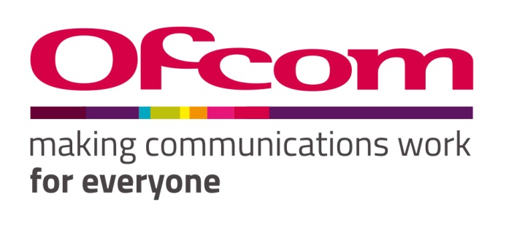

Consultation response form
Please complete this form in full and return to ian.strawhorne@ofcom.org.uk.
Consultation title | Approval of Phone-paid Services Authority’s Code of Practice (fifteenth edition)
Full name | Paul Muggleton
Contact phone number | 07803 011304
Representing (delete as appropriate) | Organisation
Organisation name | Phone-paid Services Consumer Group
Email address | paul@psconsumers.org.uk

Confidentiality
We ask for your contact details along with your response so that we can engage with you on this consultation. For further information about how Ofcom handles your personal information and your corresponding rights, see Ofcom’s General Privacy Statement.
Your details: We will keep your contact number and email address confidential. Is there anything else you want to keep confidential? Delete as appropriate. | Nothing
Your response: Please indicate how much of your response you want to keep confidential. Delete as appropriate. | None
For confidential responses, can Ofcom publish a reference to the contents of your response? | Yes

Your response
Question | Your response
Question 1: Do you consider Ofcom should approve the PSA’s 15th Code of Practice in its current form? Please provide an explanation to support your response. | Confidential? – N  We do not feel that, as it stands, the revised Code is an adequate response to the consumer harm created by bad actors in the Phone-paid Services Industry. Much of this stems from limitations imposed on PSA by Ofcom. We support the principle that prevention is better than cure. However, unless preventative measures are backed up by the ability to enforce, they are unlikely to succeed. Enforcement by PSA has been dismal in recent years with only a handful of cases being pursued through a Tribunal. Whilst Tribunals have handed out substantial fines, few of these have been paid and few consumers have received refunds of unlawful charges as a result of these Tribunals.  It is essential that the role of the networks in facilitating, and profiting from, harmful Phone-paid Services is properly recognised and that measures are in place to hold them to account when their negligence results in consumer harm. Recent years have seen widespread consumer harm from “services” which appear to have been deliberately created to exploit vulnerabilities in the direct carrier billing and reverse premium SMS payment mechanics. Networks have contracted with payment intermediaries who have clearly been acting unlawfully in onboarding companies which they knew, or ought to have known, would engage in such exploitation. We were delighted in September 2019 when PSA finally took action against a payment intermediary that had been facilitating fraudulent charges. However, it shouldn’t have needed a PSA Tribunal to tell networks that Veoo had been breaching the PSA Code. It was clear to anyone monitoring complaints that there was an issue with this company and it is disgraceful that networks continued to partner with this company. There other intermediaries who we believe to have been equally negligent, but against whom PSA have failed to act.  The Phone-paid services Consumer Group (PSCG) is a consumer group representing and assisting individuals who have received unexpected and/or unlawful charges through Phone-paid Services of the type regulated by PSA.  We launched a website payforitsucks.co.uk in response to widespread consumer dissatisfaction and complaints about seemingly fraudulent charges. The networks’ “Payforit” scheme has since been abandoned, the name having become synonymous with “scam”. However, although “Payforit” no longer exists, the individual networks continue to allow Direct Carrier Billing and Reverse Premium SMS charges by third parties to consumers’ phone bills. It is the widespread abuse of these mechanisms that Payforitsucks and PSCG were created to oppose.  The vast majority of Phone-paid Services cause few problems or complaints. Where a service is initiated by sending a text or by making a premium rate call, there is clear evidence available to the network operator that the consumer took action which initiated charges. There may be disputes about the circumstances in which the chargeable call or text was originated, the level of the charges themselves, or the nature of any subscription, but networks hold incontrovertible proof that the consumer’s handset made the call or text in question. The revised PSA Code deals well with such cases. We have seen development of malware which can initiate charges by sending Premium Texts, but as yet this has caused few problems in the UK.  Our concern relates primarily to those services, usually subscription services, for which the responsibility for obtaining proof of consent to charge currently rests solely with a service provider. It is contrary to natural justice that consumers are hounded by MNOs for payment of debts which cannot be proved to be lawful.  There has, for some years, been an issue with services initiated by interaction with a web interface. In such cases consumers frequently deny having consented to the charges which have appeared on their phone bills. These charges take the form of Direct Carrier Billing (where the charges are applied directly to the consumer’s phone bill) or Reverse Premium Rate Texts (where a consumer is charged for RECEIVING a text).  Consumers frequently deny having provided their phone number to a service provider in order to initiate these charges. However, they do not need to have done so. When a consumer accesses the internet using their networks mobile data (3G, 4G or 5G) a process known as MSISDN passthrough can be used by service providers to obtain the consumer’s phone number directly from the network. We have seen cases where consumers have become “subscribed” to such services simply by them clicking to close an unwanted popup.  BBC Watchdog commissioned a report which highlighted the danger of fraudulent “subscriptions” being initiated in this way by exploits embedded in web sites or via malicious phone apps. The Multi Factor Authentication requirement introduced by PSA as a special condition has temporarily reduced the scale of this abuse, but we have no doubt that before long the fraudsters will catch up and find ways of circumventing these safeguards. We have already seen several attempts to circumvent the One Time PIN authorisation process  When consumers query such unexpected charges, they are told to discuss the matter with the “service provider” who initiated the charges. Such service providers can be difficult to contact and are often based overseas. They often employ third party call handling services whose role appears to be to prevent the consumer making direct contact with the service provider. The Mobile Networks insist that the purported contract under which the charges were taken was between the “service provider” and the consumer. We normally advise consumers to ask the service provider for proof that they entered in to a contract with them. Such proof is rarely forthcoming. When consumers claim that they didn’t consent to charges, they usually receive some response to the effect that they must have consented by clicking a link. Very rarely is proper evidence of consent provided to the consumer. PSA seem content with this situation which actually runs counter to the law. Under the Consumer Contracts (Information, Cancellation and Additional Charges) Regulations 2013(Part 2, Chapter1, Reg 17), where the existence of a contract is disputed, the burden of proof rests with the service provider to establish the existence of that contract. The consumer shouldn’t have to prove that they didn’t subscribe, the service provider should have to prove that they did! The current (weak) PSA guidance does not accurately reflect this, and it is not uncommon for merchants to ask consumers to prove that they didn’t consent to a contract. Not fair, and not in compliance with UK contract law. Under UK Consumer Law, the burden of proof in circumstances like these rests entirely with the merchant. If the Merchant can’t show the existence of a lawful contract, any charges taken were unlawful and should be fully refunded.  Sadly, we rarely see service providers willingly refunding in such circumstances. Often, they seek to haggle with the consumer, offering a derisory amount as a refund. Consumers frequently report giving up and writing off their losses  Unlike FCA approved payment processors, the mobile networks offer no mechanism for dealing with such contractual disputes. Any reputable payment processor, when a payment is queried, will be able to tell you full details of the payment including when and where the payment was authorised and the method of authorisation used. Any reputable payment processor will offer a formal procedure for consumers to dispute charges. Mobile networks are unwilling to offer even this basic level of service to consumers who believe they may have been defrauded. Furthermore, they refuse to put a stop to further unlawful charges being taken. With other payment mechanisms, consumers have come to expect to be able to exercise some level of control over payments, so it comes as a shock that this antiquated system is unable to even stop the equivalent of a direct debit!  Some consumers choose to refuse to pay these charges when they appear on their bill. We strongly advise them not to do this. Although the charges are probably unlawful, and the networks hold no evidence to the contrary, they are ruthless in invoking their debt collection processes in such cases. Our advice to consumers is that they should pay their bill and then seek to recover a refund from the service provider.  When dealing with a UK based service provider, we encourage and support consumers to pursue their losses through legal action using the Small Claims procedure. This usually results in a full refund, but is unnecessarily stressful for the consumers concerned. We have even seen cases where consumers have obtained CCJs against service providers, which have gone unsatisfied despite the service continuing to operate!  The networks also make it difficult for consumers to opt out of this payment mechanism. One of the major networks and several MVNOs offer no means of opt out. We believe that all networks should be required to provide such an opt out – something which PSA tell us they have no power to require.  Furthermore, we believe that charge caps should apply to such services. The situation here is unclear, even to the customer service representatives of the networks. It appears that on most, but not all networks, charge caps do not apply to “third party charges”. This is contrary to the normal expectation of consumers and needs to be corrected. We frequently hear complaints from consumers who believe that they were misled by their networks about this. Parents complain that their children were able to run up large phone bills by using third party services despite them taking the precaution of imposing a spending cap.  A further issue relates to charging by Reverse Premium Rate Texts (RPSMS). We believe that consumers should NEVER be charged for RECEIVING a text. Such a charging mechanism is open to wholesale abuse, as has been shown by recent events.  On the evening of 25th September 2020 we began to receive reports from consumers of receiving a succession of Premium Texts from the 84222 shortcode operated by Tap2Bill. The texts purported to be from a service called Free(b) operated by Moblix Media Ltd and were charged at £1 each. Some consumers reported receiving over 150 such texts over the course of a few minutes, with each text charged at £1. We estimate that well over 6,000 consumers received these texts, and that the total value of the unlawful charges was in excess of £600,000. Indeed, had the intermediary not acted swiftly to prevent the sending of further texts, many more consumers would have been affected. This highlights the fact that no checks are made on the sending of these texts. It appears that the consumers who received these charges may have provided their number in relation to a totally different non-chargeable service, and that these numbers were unlawfully added to the subscription database for the service in question. Whether this was deliberate or accidental remains a matter for investigation, but it highlights the fact that networks do not verify consumer consent before applying these charges.  We reproduce below a small selection of the consumer complaints and network responses at the time of this incident.  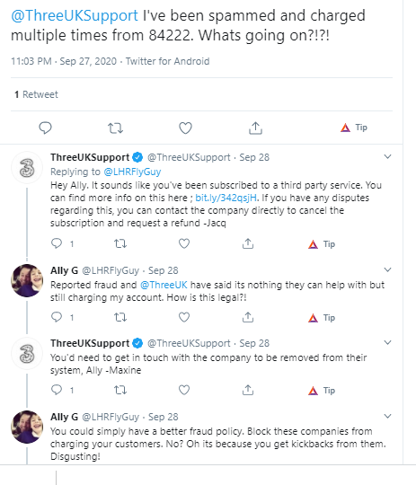  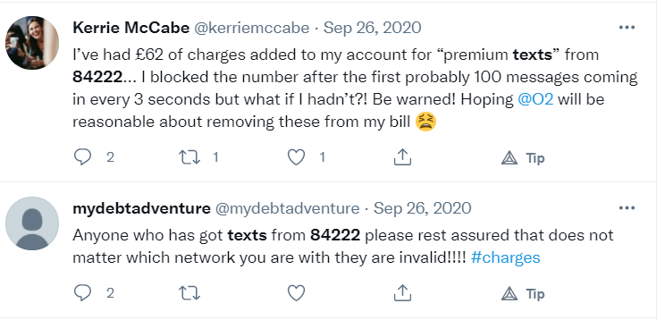  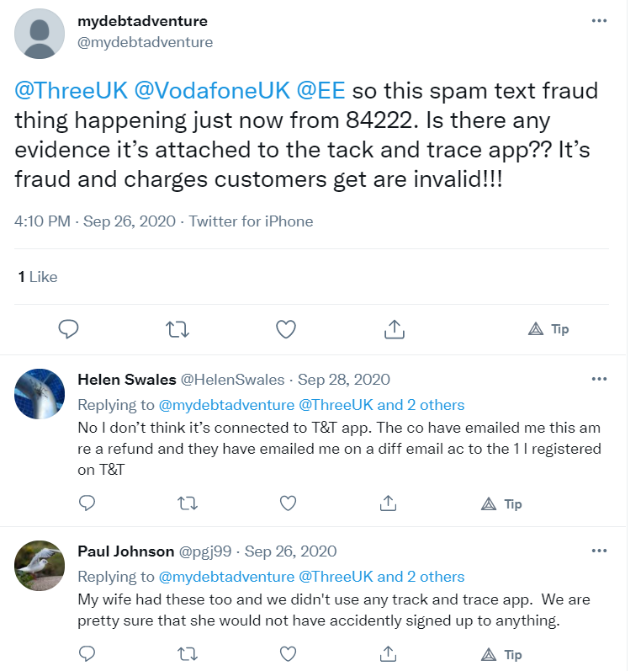  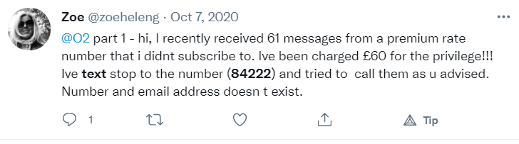  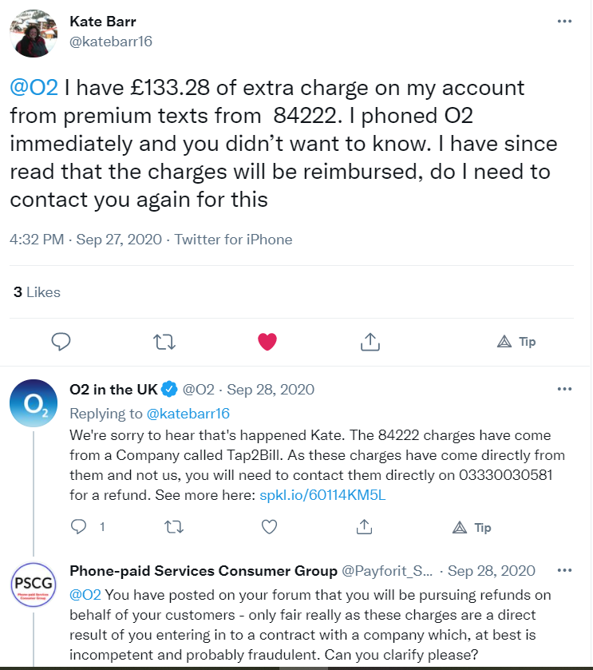  As can be seen from the network responses above, the consumers affected by this incident received the usual “it’s nothing to do with us” response from their networks. Eventually most consumers were refunded, but this took weeks, when most reputable payment systems would have been able to do it in days. These charges were indisputably unlawful and should never have made it on to consumers’ accounts.  We believe that the mechanisms for charging “third party services” need review and modernisation. Consumers want and expect to have greater control over their spending than is offered by the DCB and RPSMS systems.  The networks make a great deal of money through these services. While publicly denying this, research into the figures provided by PSA Tribunal cases, shows that networks receive approximately 25%-30% of the charges made by these services. After the Payment Intermediary has taken their cut, and VAT has been paid, the service provider will be lucky to see 50% of the charges. It is unsurprising therefore, that these services often represent very poor value for money.  Para 6.78 of the Ofcom 2012 review of PRS highlighted the dangers of a fragmented supply chain such as that involved in these services and the unreliability of “consent” obtained in these circumstances:  “6.78 This scam demonstrates how a fragmented supply chain, with separation between the service provider and the billing party, can be exploited in an (unlawfully) opportunistic way. The greater transparency of PFI services would not prevent this harm. Rogue software can be embedded in such a way as to circumvent any verifiable method of consumer consent to charges (like a PFI checkout).”  This view, expressed by Ofcom in 2012 proved to be entirely accurate. PFI (Payforit) showed itself to be highly vulnerable to fraud and was abused by bad actors in the industry to the point where it had to be abandoned in 2019.  In appendices to the same review, the networks provided information about their compliance monitoring and consumer support. These proved to be empty words, with the networks abrogating any responsibility for Payforit fraud.  The concept behind Code 15 is good. By requiring Due Diligence Risk Assessment and Control (DDRAC) of parties entering in to contracts within the value chain, it is hoped that these parties will behave more responsibly in selecting the partners they choose to do business with. The code envisages a failure to comply with these requirements to be a breach of the code, resulting in sanctions against the negligent party. An essential part of the relationship between the parties is the relationship between the MNOs and the payment intermediaries. To approve Code 15 without providing PSA with the power to enforce against a MNO where it has been negligent in its DDRAC would be madness. We know from the Payforit experience that MNOs will contract with any payment intermediary that can create a profit for them.  When consumers looked for the Payforit T’s and C’s they were shown this screen.  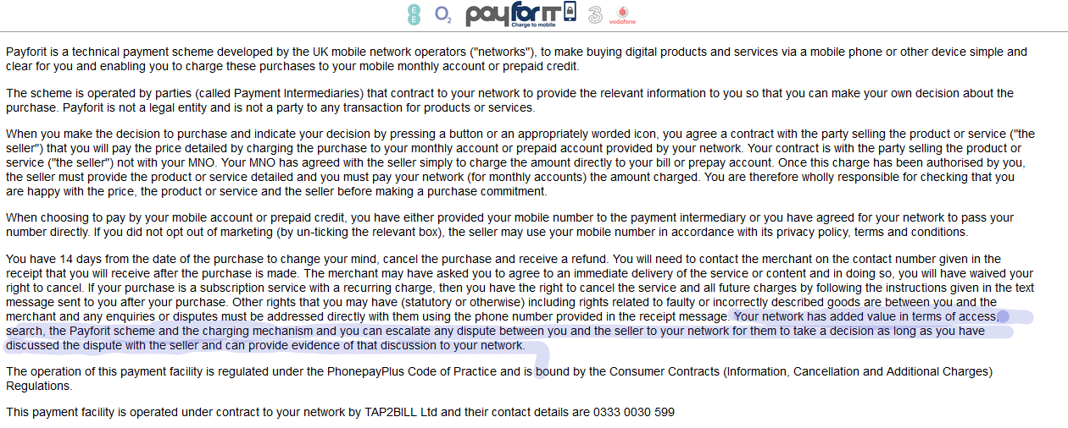  Note that consumers were told that after discussing their issue with the seller they could escalate their dispute to their network if they were not satisfied. We are not aware of a single case where the network honoured this commitment and accepted responsibility for resolving the dispute – if they had, a large number of Small Claims cases could have been avoided. One of the MNOs even gave this commitment to consumers on their website:  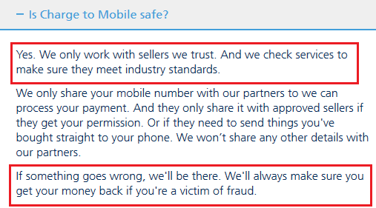  Far from ensuring that victims of fraud recovered their money, this network aggressively pursued consumers for payment of bogus charges which they were unable to substantiate.  These consumers were left with nowhere to turn to resolve their complaints. The Communications Ombudsman claimed to lack power to hold the networks to their commitments, referring consumers to the PSA. In turn the PSA had no power to enforce against the networks and in any event would not get involved in individual complaints.  PSA need to be able to enforce against networks, in the same way as they currently do against Payment Intermediaries and Service Providers. Unless they are able to do this effectively, the strategy envisaged by Code 15 will not work.  Unless it is possible to make networks take responsibility when they enter in to contractual relationships with companies which have a history of partnering with non-compliant services, a better solution would be to limit phone-payment to mechanics where the networks will hold clear proof of consumer consent.  Parties in the Phone-paid Services “value chain” rely on the Electronic Communications Exemption (ECE) from Payment Services Directive 2. The ECE excludes payment transactions by a provider of electronic communications networks or services where these are provided in addition to electronic communications services provided to a customer. The ECE is limited to the purchase of digital content and voice-based services. It also includes charitable giving and the purchase of tickets but only via electronic devices, charged to the subscriber’s bill. The ECE also introduces value limits for transactions that are within the ECE.  The European Banking Authority have expressed the view that this exemption should apply only to providers who have a direct contractual relationship for the provision of communication services to the consumer and therefore should not apply to the payment intermediaries within the value chain. In the UK we have taken a different view and allowed the ECE to “cascade” down the value chain to other parties. However, there should be no doubt that these other parties are taking advantage of an exemption that has been granted to the consumer’s communication service provider, by virtue of their contractual relationship with the consumer. In such circumstances we feel that it essential to be able to hold networks to account when they “cascade” the exemption to parties who proceed to abuse it.  In summary, we believe that the mobile networks have been instrumental in widespread consumer harm from Phone-paid Services. PSA have been hampered in their regulation of the sector by their inability to hold MNOs to account for failure to perform proper DDRAC on the payment intermediaries with which they contract. We believe that the PRS Condition needs to be amended to ensure that telecommunications providers can be held directly responsible for abuses with a system which they have devised and which they oversee. Where consumers dispute a third party charge on their bill, they should be provided with the evidence that it was lawful, or it should be written off. The responsibility for this should rest with the network, as it is they who will ultimately take action to enforce any resulting debt.
Question 2: Do you have any views on the appropriate implementation period? | Confidential? N  No.

Please complete this form in full and return to ian.strawhorne@ofcom.org.uk.

